**Developers Guide**

**E-Project (1st Semester)**

**WATER WORLD**



Faculty: **SIR MUHAMMAD ATIF**

BATCH: **2410G3**

CURRICULAM: **7144**

**WATER WORLD**

**Group Members:**

|  |  |  |
| --- | --- | --- |
| **S.R** | **Name** | **ID No** |
| 01 | SAEED UR REHMAN | Student1616764 |
|  |  |  |
|  |  |  |
|  |  |  |
|  |  |  |



**TABLE OF CONTENTS**

Contents

Acknowledgements 4

Abstract 5

Project Duration 6

Project Synopsis: 6

Project Analysis: 6

Project Design: 6

Data Flow Diagrams (DFDs): 7

Context Diagram: 7

Flowchart: 9

Screenshots: 10

Conclusion 24

# Acknowledgements

We would like to express our sincere gratitude to **Aptech** for their valuable support and guidance in the development of this project. Special thanks toour Faculty teacher **Sir M. ATIF** for their invaluable guidance, support, and encouragement throughout the development of this project. Their insights and constructive feedback played a crucial role in shaping this project into its final form.

I would like to acknowledge the contributions of **online resources, research papers, and documentation** that provided the necessary technical knowledge and solutions to challenges faced during development.

Finally, I extend my appreciation to **everyone who tested and reviewed the project**, providing valuable suggestions to enhance its functionality and user experience.

This project would not have been possible without the collective efforts of all those mentioned above. Thank you for your support and encouragement!

**SAEED UR REHMAN**

**24-Mar-2025**

# Abstract

The **Water World** project is a web-based platform designed to provide users with information about various attractions, rides, and services available at the water park. The website enhances user experience by offering seamless navigation through sections such as **Home, About, Booking, Attractions, Services, Rides, and Contact Us**.

The platform aims to improve customer engagement through an interactive **booking system**, ensuring a hassle-free ticket reservation process. Additionally, it incorporates **user-friendly design, real-time updates, and an intuitive interface** to provide an engaging experience for visitors. The website follows structured **Data Flow Diagrams (DFDs), Flowcharts, and Process Diagrams** to ensure smooth operations and logical data processing.

This report details the **project synopsis, analysis, and design**, including database structure, screenshots, source code, and user and developer guides. The implementation leverages **modern web technologies such as HTML, CSS, JavaScript** ensure efficiency, responsiveness, and scalability.

Through this project, **Water World** aims to enhance the accessibility and convenience of water park visitors, making their experience more enjoyable and well-organized.

# Project Duration

|  |  |
| --- | --- |
| Analysis | 02-Days |
| Design | **06-Days** |
| Development | **11-Days** |
| Documentation | **02-Days** |

# Project Synopsis:

The Water World project aims to create an interactive and engaging platform that provides users with information and services related to water parks. The project includes features such as ticket booking, ride details, safety guidelines, and an immersive user experience.

# Project Analysis:

This section covers the analysis of the project requirements, feasibility study, and objectives. The key focus areas include:

* Identifying the target audience
* Understanding user requirements
* Researching similar platforms
* Setting up development goals

# Project Design:

This section outlines the architectural and UI/UX design principles applied to the project.

# Data Flow Diagrams (DFDs):

A **Data Flow Diagram (DFD)** visually represents how data moves through a system. Below is a **DFD for the Water World Project**:

## Context Diagram:]

This represents the entire system as a single process interacting with external entities.

**Entities:**

1. **User** (Customer) → Books tickets, checks ride details.
2. **Admin** → Manages bookings, updates ride details.
3. **Payment System** → Handles online payments.

**Processes:**

* Ticket Booking
* Ride Information Management
* Payment Processing

**Data Stores:**

* User Database
* Booking Database
* Payment Records

**Level 1: Detailed DFD:**

This breaks down the main system into specific processes.

**Processes:**

1. **User Registration/Login:**
   * Inputs: Name, Email, Password
   * Output: User Profile
2. **Browse Rides & Attractions:**
   * Inputs: Ride Category, Age Group, Preferences
   * Output: Ride Details
3. **Book Tickets:**
   * Inputs: Ride Selection, Date, Number of Tickets
   * Output: Booking Confirmation
4. **Payment Processing:**
   * Inputs: Card/UPI Details, Amount
   * Output: Payment Receipt
5. **Admin Management:**
   * Inputs: New Rides, Ticket Prices
   * Output: Updated System Information

# Flowchart:

Flowcharts provide a visual representation of the logical flow of the application, ensuring clarity in process design.

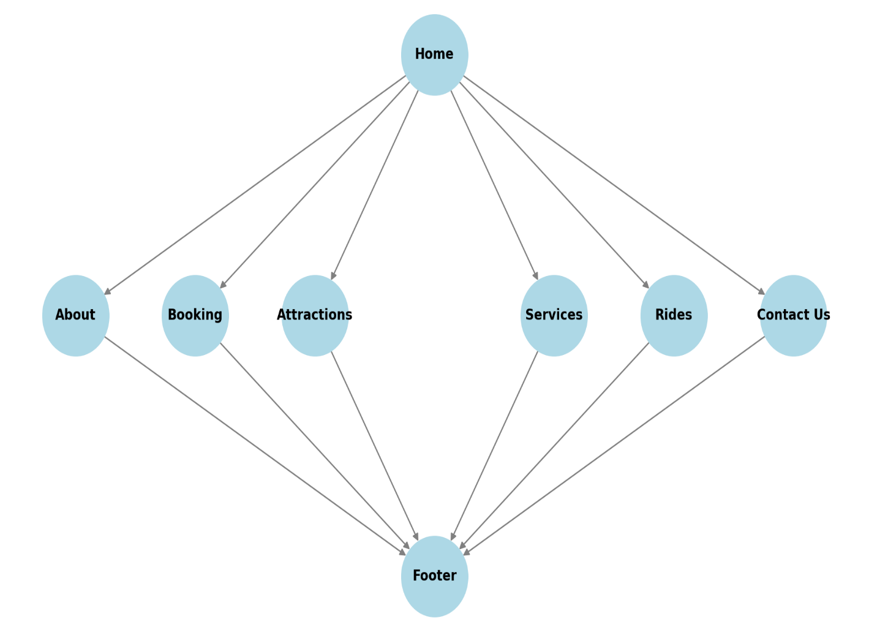

# Screenshots:

This section contains description & images of the application interfaces, showcasing the homepage, booking system, ride details, and user interactions etc.

**Introduction:**

**Water World** is a premier water park designed to offer thrilling and refreshing entertainment to visitors of all ages. It features a variety of attractions, including exhilarating water slides, wave pools, lazy rivers, and interactive play areas. The park is built to provide an immersive experience where guests can escape the heat, enjoy adventure-filled rides, and create unforgettable memories with family and friends.

Whether visitors are looking for adventure, relaxation, or a family-friendly outing, **Water World** promises an unforgettable experience filled with excitement and fun.

**Index**

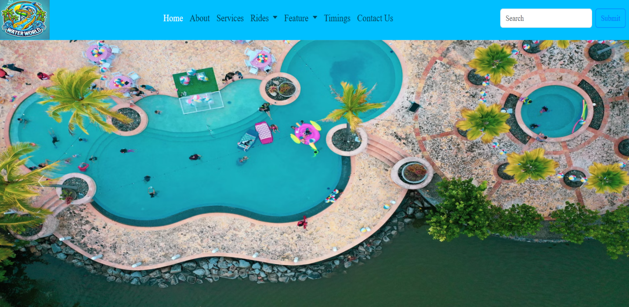

The Water World website features a user-friendly navigation bar and an engaging carousel to enhance the user experience.

**Navbar Functionality:**

* The navbar provides seamless navigation across key sections, including Home, About, Booking, Attractions, Services, Rides, and Contact Us.
* It is designed to be responsive, ensuring smooth adaptability across various screen sizes.
* Dropdown menus and interactive hover effects improve accessibility and usability.

**Carousel Functionality:**

* The homepage features a dynamic image carousel that showcases stunning visuals of Water World’s attractions, rides, and services.
* The carousel is auto-playing, with smooth transitions between slides, creating an engaging experience.
* Users can manually navigate between images using left and right navigation arrows or pagination indicators.
* Implemented using CSS animations and JavaScript/jQuery, ensuring fluid motion and responsiveness.

**Booking**

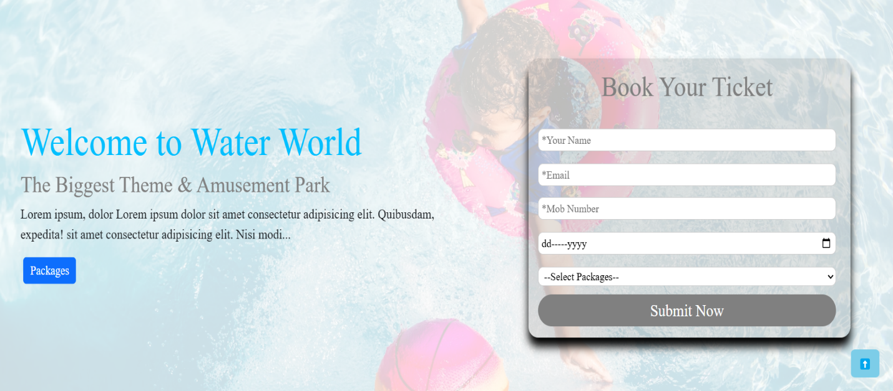

Booking your visit to Water World is simple and convenient! Whether you're planning a fun family day, a group trip, or a special event, we offer multiple ways to secure your spot at our water park.

**Booking Details:**

**Online Booking:**

* Visit our official website and navigate to the "Booking" section.
* Choose your ticket type (Single-Day Pass, Family Pack, VIP Experience, etc.).
* Select your preferred date and time.
* Make a secure online payment and receive an e-ticket via email.

**On-Site Booking:**

* Walk in and purchase your tickets at our ticket counters.
* Subject to availability, so we recommend arriving early on peak days.

**Group & Event Bookings:**

* Special discounts are available for large groups, corporate events, school trips, and birthday parties.
* Contact our customer service team to customize your package.

**Payment Methods Accepted:**

Credit/Debit Cards  
Mobile Wallets  
Cash (for on-site bookings)

**Cancellation & Rescheduling:**

* Tickets are non-refundable but can be rescheduled based on availability.
* Weather-related closures will be accommodated with alternative dates.

**About**

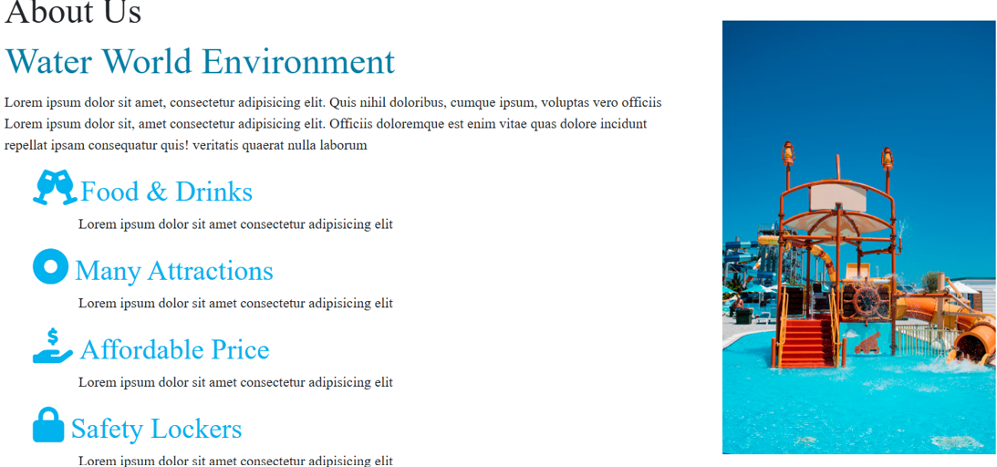

**Water World** is a state-of-the-art water park dedicated to providing an exhilarating and refreshing escape for visitors of all ages. Designed with a perfect blend of adventure, relaxation, and family-friendly entertainment, the park features a diverse range of attractions, including:

**Thrilling Water Slides** – Experience high-speed twists, turns, and drops on our adrenaline-pumping slides.  
**Wave Pool** – Feel the rush of ocean-like waves in a safe and controlled environment.  
**Lazy River** – Drift along a serene waterway, perfect for relaxation.  
**Interactive Play Zones** – Splash and play in specially designed areas for children and families.  
**Food & Refreshments** – Enjoy delicious meals and beverages from our on-site restaurants.  
**Event & Party Hosting** – Celebrate birthdays, corporate outings, and private events in a fun-filled setting.

At Water World, safety and guest satisfaction are our top priorities. Our facilities are maintained to the highest standards, with lifeguards and trained staff ensuring a safe and enjoyable experience for everyone.

**Services**

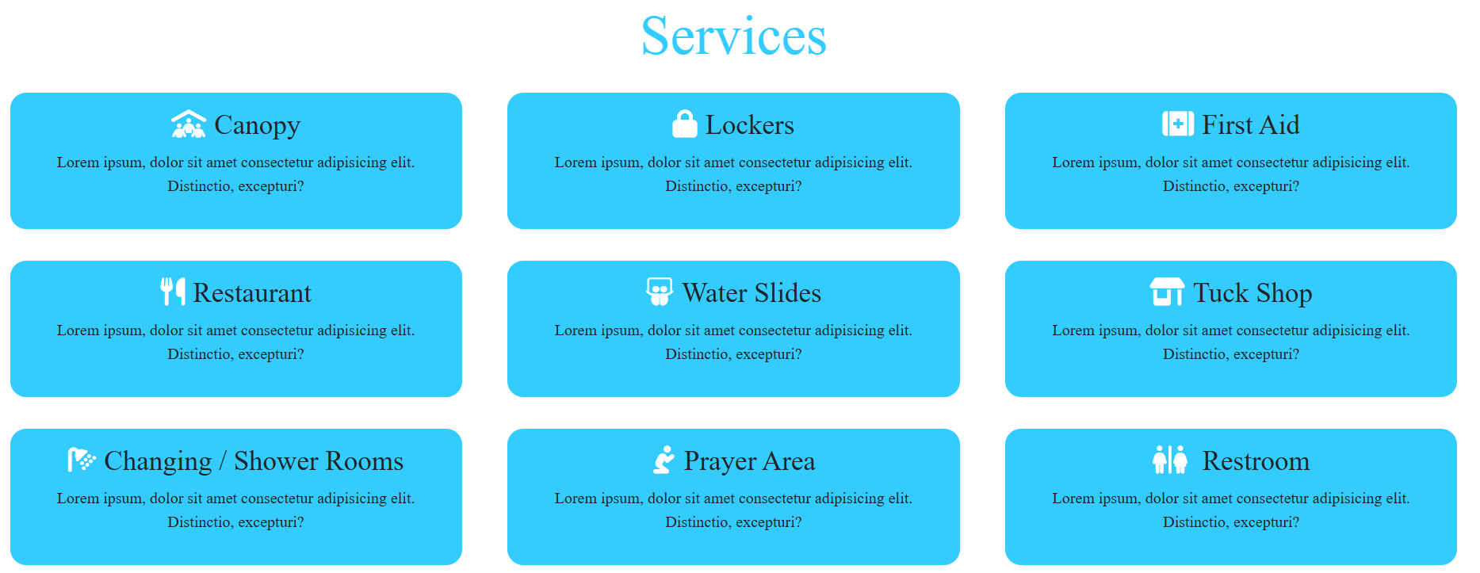

At **Water World**, we offer a range of services to ensure a fun, safe, and hassle-free experience for all our visitors.

**Ticketing & Booking Services:**

* **Online & On-Site Ticket Purchase**: Easy and secure ticket booking options.
* **Group & Event Bookings**: Special packages for corporate events, school trips, and birthday celebrations.
* **Fast Pass Access**: Skip the lines and enjoy priority entry to rides.

**Attractions & Rides Services:**

* **Wave Pool**: Experience ocean-like waves in a safe environment.
* **Thrilling Rides**: Enjoy exciting water slides, lazy rivers, and splash zones.
* **Kids' Play Area**: Safe and fun water activities for young visitors.

**Food & Refreshments:**

* **Food Courts & Restaurants**: A variety of food options, including fast food, snacks, and beverages.
* **Cafés & Ice Cream Stands**: Cool off with refreshing drinks and treats.

**Guest Facilities:**

* **Changing Rooms & Showers**: Clean and spacious areas for freshening up.
* **Lockers & Storage**: Secure lockers available for personal belongings.
* **Lost & Found**: Assistance in locating lost items.

**Safety & Medical Services:**

* **Lifeguards on Duty**: Professional lifeguards ensuring water safety.
* **First Aid Stations**: Quick medical assistance for minor injuries.

**Shopping & Rentals:**

* **Gift Shops**: Buy Water World souvenirs, swimsuits, and accessories.
* **Cabana & Tube Rentals**: Relax in private cabanas or rent floating tubes for a smooth ride.

**Photography & Memories:**

* **Photo Booths & Park Photography**: Capture your fun moments with professional photos.

**Rides**

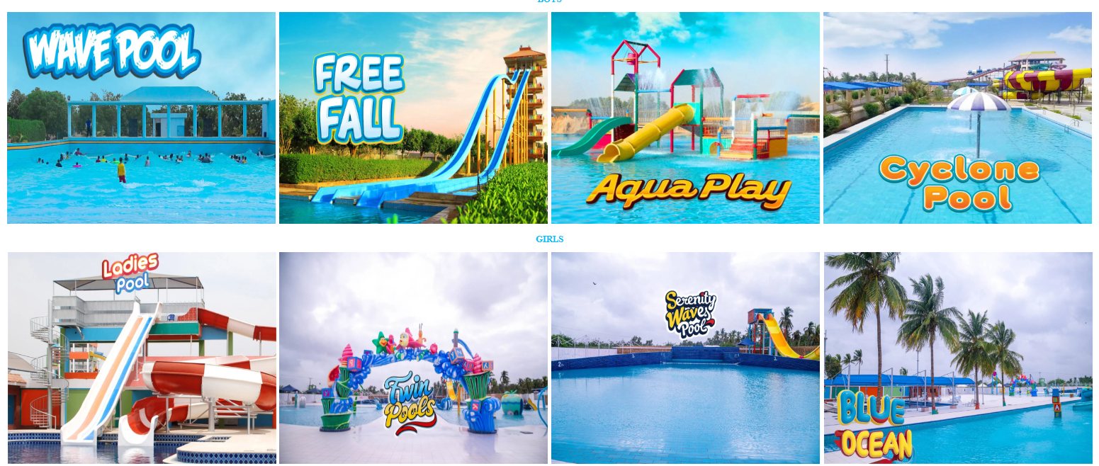



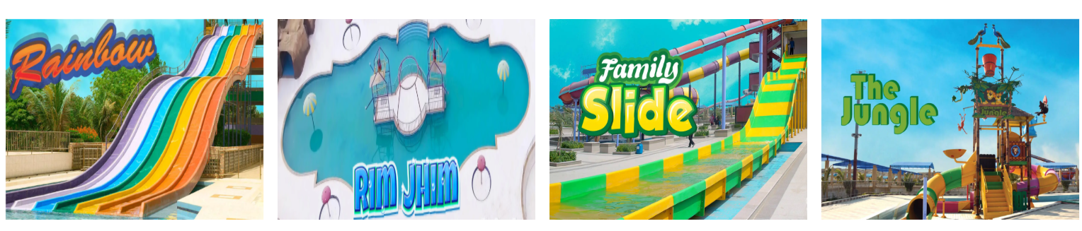

At **Water World**, we offer a variety of adrenaline-pumping rides and family-friendly attractions to ensure a fun-filled experience for all visitors. Here’s a look at some of our **top rides**:

**Wave Pool:**

* Experience the excitement of ocean-like waves in a safe and controlled environment.
* Perfect for families, swimmers, and those who love to float with the waves.

**Turbo Cyclone:**

* A high-speed, twisting water slide that takes you through thrilling turns and drops.
* Ideal for adventure seekers looking for a rush of excitement.

**Free Fall:**

* A giant ride where you slide down a steep drop and swirl inside a massive vortex.
* Perfect for those who love extreme rides with unexpected.

**Aqua Play:**

* A nearly vertical water slide that gives you the sensation of free-falling before splashing into the pool.
* Designed for thrill-seekers who crave high-speed drops.

**Serenity Waves Pool:**

* A slow-moving, relaxing water ride where you can float along a winding river.
* Perfect for unwinding and enjoying the scenic views of the park.

**Boomerang:**

* Ride down a steep drop, then swing back and forth on a giant U-shaped slide.
* Exciting yet smooth, making it fun for all age groups.

**Rainbow Racer:**

* A multi-lane slide where riders race head-first down a series of dips and turns.
* Great for competitive fun with friends and family.

**Jungle Slide:**

* A long, winding water slide with twists and tunnels that make you feel like you're riding on a dragon’s tail.
* Perfect for those who enjoy a mix of speed and adventure.

**Kids’ Splash Zone:**

* A fun-filled area with mini slides, fountains, and water play structures for children.
* Designed for safe and exciting water adventures for young guests.

**Gallery**

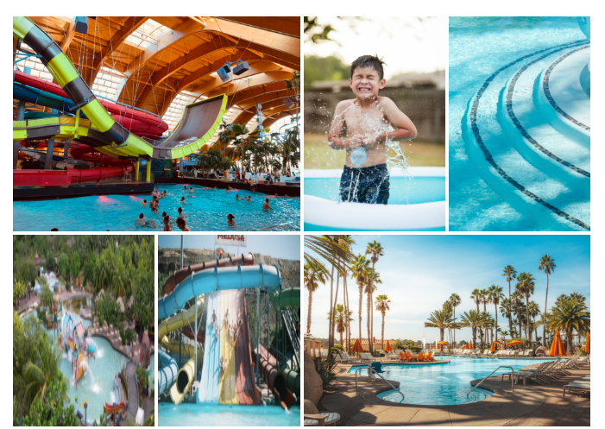

Step into a world of fun and adventure with our exciting collection of **Water World** images! From thrilling rides to relaxing attractions, our gallery captures the best moments of your visit.

**Featured Categories:**

**Thrilling Rides** – Action-packed photos of our most popular water slides and attractions.  
**Wave Pool Fun** – Catch the best shots of guests riding the waves.  
**Family Moments** – Heartwarming pictures of families enjoying their time.  
**Night Views** – Stunning visuals of Water World lit up in the evening.  
**Events & Celebrations** – Special occasions, birthday parties, and summer events.

**Team Members**

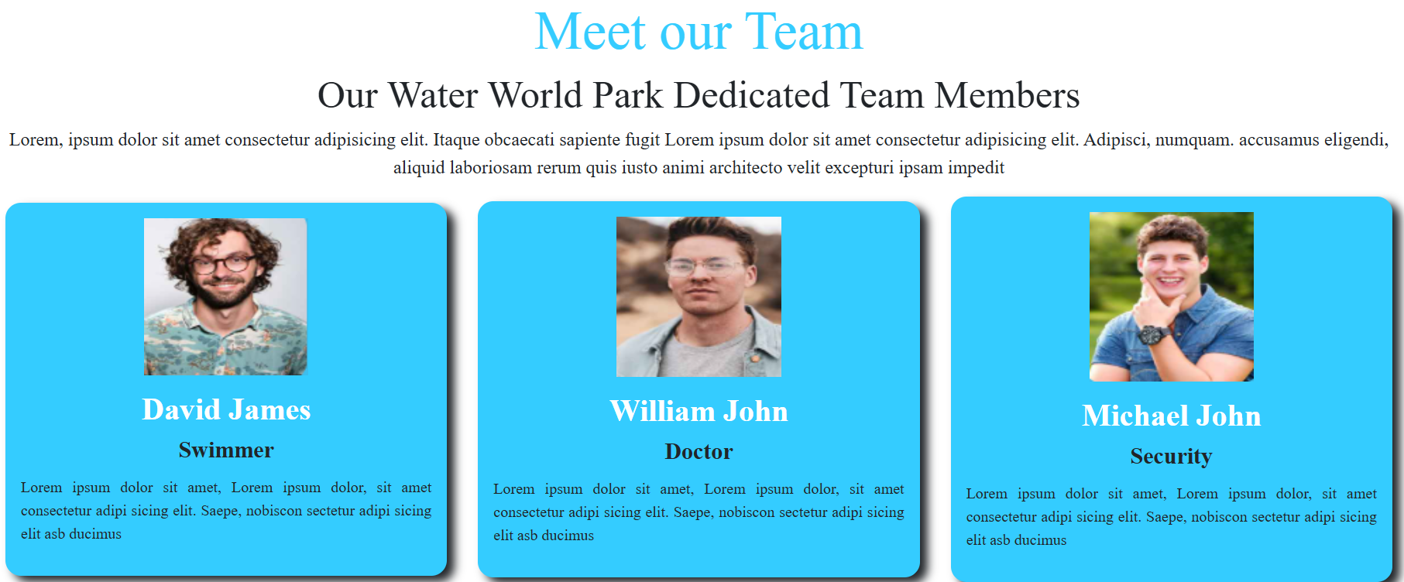

At Water World Park, our team is committed to ensuring an unforgettable experience for our visitors. From safety to entertainment, our dedicated professionals work tirelessly to provide a fun, secure, and exciting environment for all. Meet the passionate individuals who make it all happen!

**David James**

**Professional Swimmer & Lifeguard:**  
With over 10 years of experience in water safety and competitive swimming, David ensures the highest safety standards at Water World Park. He leads our lifeguard team, conducts water rescue drills, and provides swimming lessons for kids and adults. His goal is to create a fun and secure environment for all guests.

**William John**

**Park Doctor & First Aid Specialist:**  
Dr. William is always ready to assist with any medical emergencies at Water World Park. With a background in sports medicine and emergency care, he oversees the park’s first aid stations, ensuring guests receive prompt medical attention if needed. His expertise keeps visitors safe and healthy during their adventures.

**Michael John**

**Head of Security:**  
Michael has extensive experience in security and guest relations. As the head of security, he ensures that all visitors have a safe and enjoyable experience at the park. From managing surveillance to coordinating emergency responses, his team works around the clock to provide a secure environment for families and thrill-seekers alike.

**Contact Us**

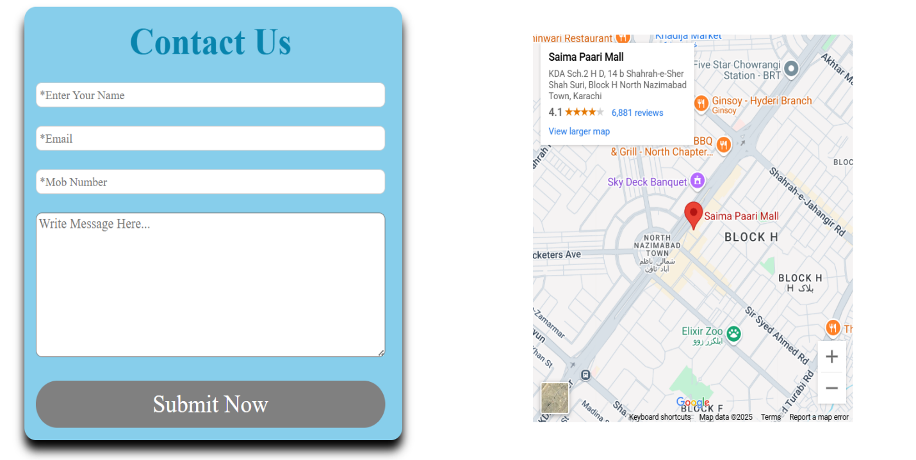

We’re here to help! Whether you have questions, need assistance with booking, or just want to share your experience, feel free to reach out to us.

**Our Location:**  
Lorem Ipsum NY-36524

**Get in Touch with Us:**

**Main Office:** +01 (123) 456-789  
**Email:** demo@gmail.com

**Send Us a Message:**

Fill out the form above and our team will get back to you as soon as possible.

**Follow Us on Social Media:**

* Instagram
* Facebook
* Twitter

**Footer**

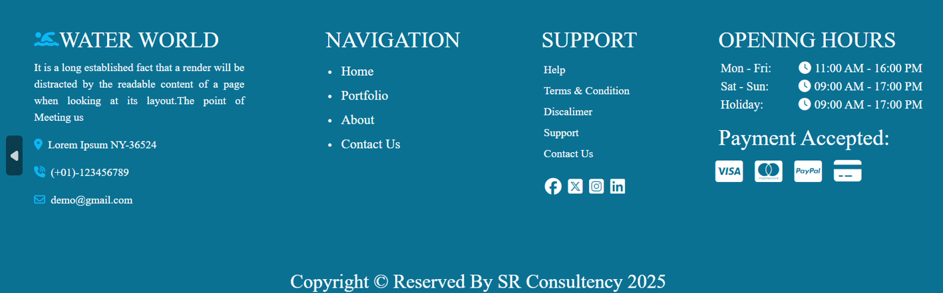

A well-designed footer provides essential information, improves user experience, and enhances site navigation. Below is an explanation of the key elements included in your **Water World** footer:

**1. Branding & Identity (Water World Park)**

* This section reinforces the park’s name and identity.
* Helps with brand recognition and provides credibility.

**2. Contact Information (Address, Phone, Email)**

* Displays the physical **location** of the park.
* Provides a **phone number** for immediate inquiries.
* Provides an **email address** for customer support and bookings.

**3. Quick Links (Navigation)**

* **Home:** Brings users back to the main page.
* **About Us:** Offers details about the park’s history and mission.
* **Gallery:** Showcases Park photos and user-generated content.
* **Contact Us:** Leads users to a dedicated inquiry form or details page.

**4. Social Media Links (Follow Us)**

* Encourages users to follow the park on platforms like **Facebook, Instagram, Twitter**.
* Helps with marketing and updates about upcoming events, promotions, and new rides.

**5. Legal & Policies (📄 Terms & Conditions, 📜 Privacy Policy)**

* Protects the business by outlining rules and guidelines for park visitors.
* Explains how personal data is used and stored, building trust with users.

**6. Copyright Notice (© 2025 Water World Park)**

* Shows ownership of website content.
* Prevents unauthorized use of branding, images, or text.

**7. Opening Hours (NEW Section)**

Providing Park timings helps visitors plan their trips. Example format:

* **Monday - Friday:** 11:00 AM – 16:00 PM
* **Saturday - Sunday:** 09:00 AM – 17:00 PM
* **Holidays:** 09:00 AM – 17:00 PM

# Conclusion

The “Water World” project is designed to offer an engaging and user-friendly experience for water park visitors. The structured design, efficient database management, and interactive UI make it a valuable tool for both users and administrators. Future enhancements could include AI-based recommendations and VR experiences for virtual ride previews.